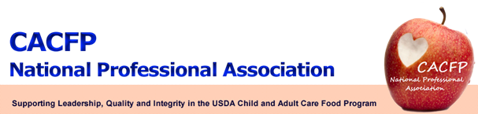

July 2012 Message of the Month

CACFP NPA Membership Updates
Please update your membership information when you get new staff and when former members leave your office. You can email these changes to Connie Bell at connie.bell@state.nm.us

VOTE! VOTE! VOTE!

Voting for the new 2013 CACFP NPA board will take place via Survey Monkey in August 2012. Please remember to vote!!

A maximum of ten votes is allowed per state, so if you have more than ten (10) NPA members, you will have to decide who will vote. We will take the first ten who vote from a state and if any additional votes come in they will be disregarded.

Core Nutrition Messages:

Check out the following website: http://www.fns.usda.gov/fns/corenutritionmessages/default.htm. This site is a good source of USDA’s 4 “core nutrition” messages – whole grains, milk, fruits and vegetables, and child feeding. Each topic has several messages, and tools. Click on the milk section and scroll to the bottom to find a fun Track and Field game!

FNS update:

- A memo will be coming out soon regarding working with Tribes in CACFP and SFSP.
- The CACFP Meal Pattern proposed rule is in clearance and still has to be reviewed by OMB which can take up to 90 days.

